**LAB – 1. IAM (Identity Access Management ).**

**Lab 1: Successfully completed lab of Create IAM Policy**

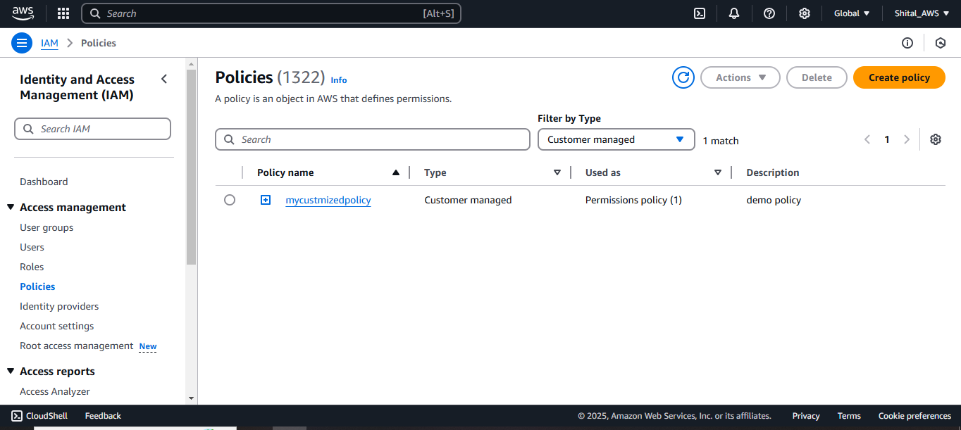

**Lab 2: Successfully completed lab of Create IAM User (For AWS Console)**

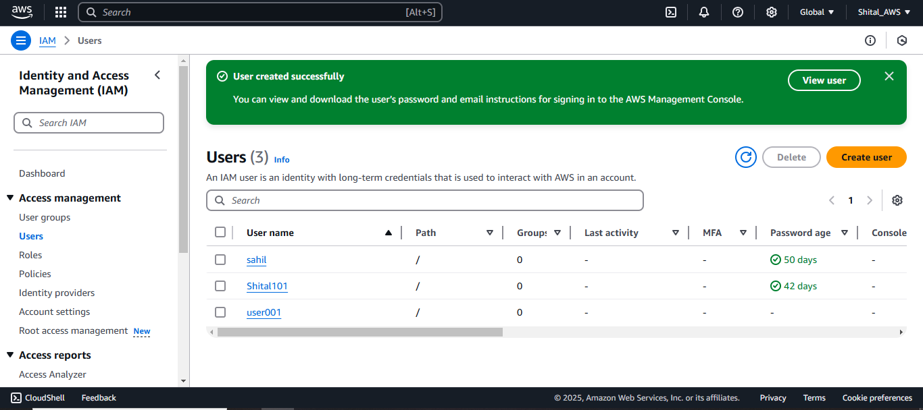

**Lab 3: Successfully completed lab of Create IAM User (For Programmatic use)**

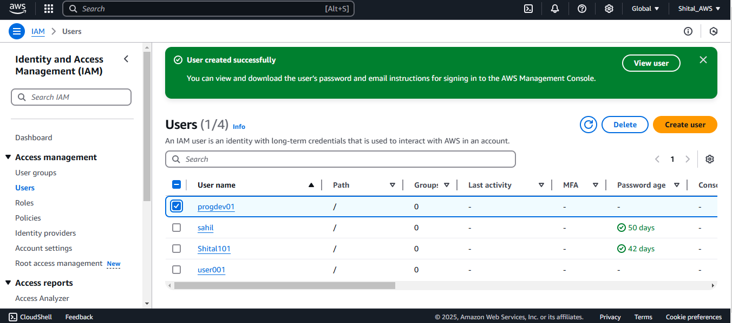

**Lab 4: Successfully completed lab of Create IAM User Group**

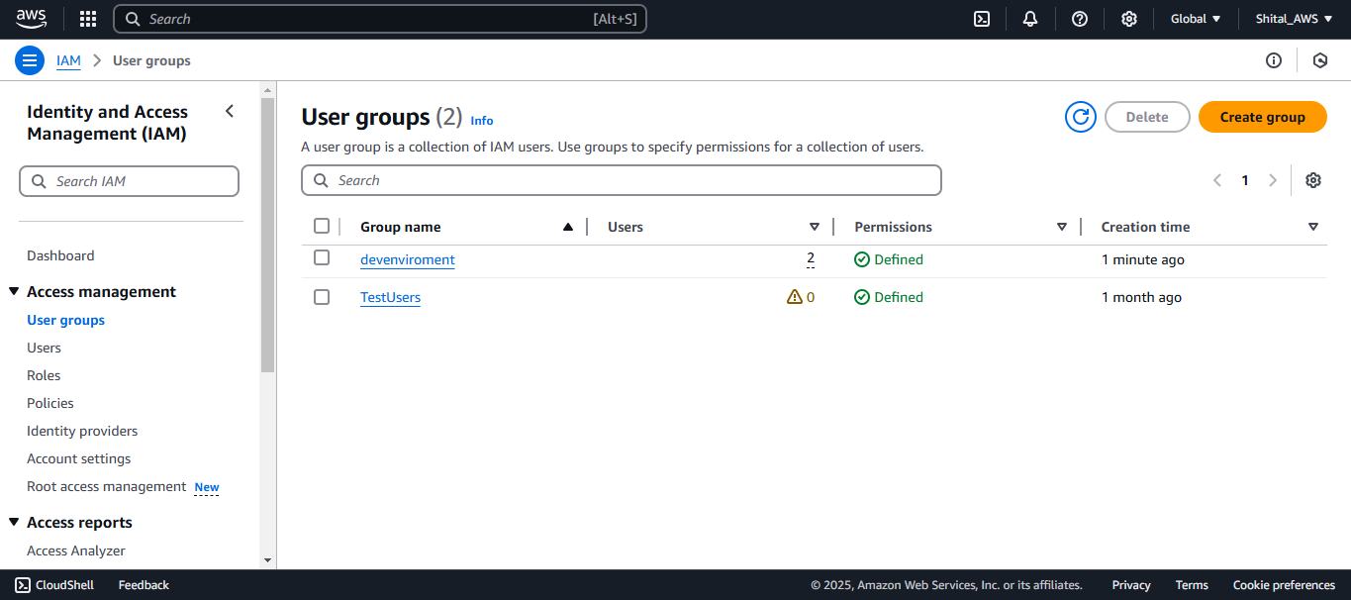

**Lab 6: Successfully completed lab of Create IAM Role**

